Delhi_AQI_Analysis
Markdown
Objective:
The objective of this project is to analyze the Delhi Air Quality Index (AQI) dataset using Python. The project focuses on understanding the distribution and relationships of major air pollutants, identifying pollution trends over time, and visualizing the data using Matplotlib and Seaborn. The analysis helps in gaining insights into Delhi's air quality and demonstrates the use of data analysis and visualization techniques for environmental data.

Tools and libraries used:
- Google Colab – To write and execute Python code.
- Python – Programming language used for data analysis.
- Pandas – For loading, cleaning, and analyzing the dataset.
- NumPy – For numerical operations.
- Matplotlib – For creating basic data visualizations.
- Seaborn – For creating advanced statistical visualizations.
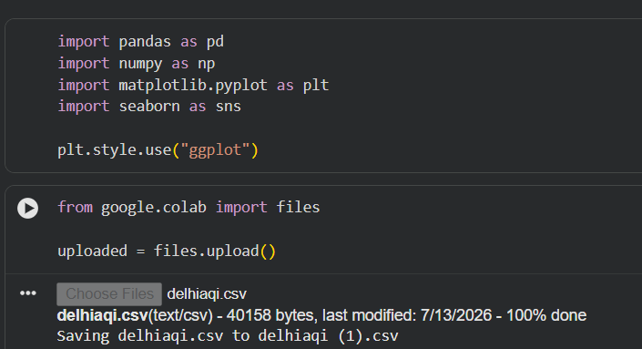

Dataset:
Dataset Name: Delhi Air Quality Dataset
Description:
The dataset contains daily measurements of major air pollutants in Delhi. It includes information about pollutant concentrations recorded on different dates.
Dataset Columns:
- Date
- CO (Carbon Monoxide)
- NO (Nitric Oxide)
- NO₂ (Nitrogen Dioxide)
- O₃ (Ozone)
- SO₂ (Sulfur Dioxide)
- PM2.5 (Fine Particulate Matter)
- PM10 (Particulate Matter)
- NH₃ (Ammonia)
The dataset was used to analyze pollutant levels, identify trends, and study relationships among different pollutants.

Analysis Performed:
The following analysis was carried out on the dataset:
- Data Loading
  - Imported the dataset into Google Colab using Pandas.
- Data Exploration
  - Displayed the first and last records.
  - Examined dataset dimensions, column names, data types, and statistical summary.
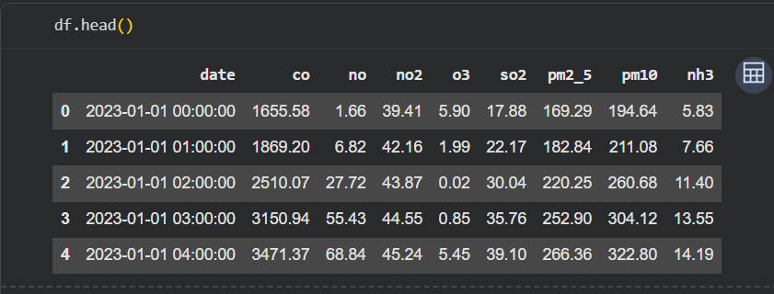
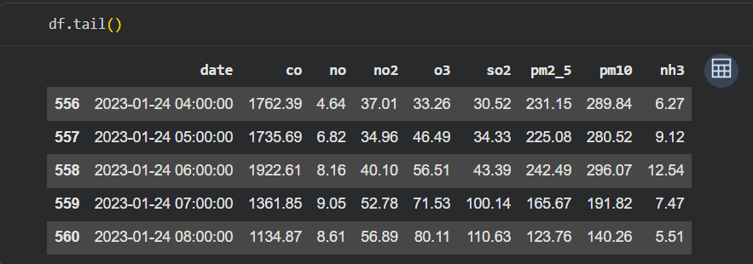
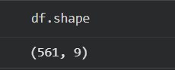
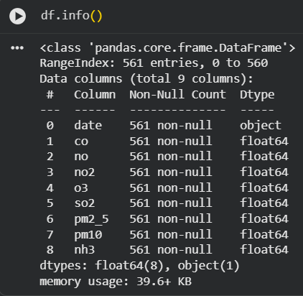
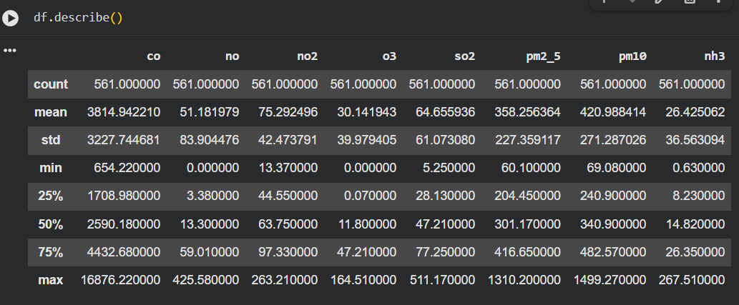

- Data Cleaning
  - Checked for missing values.
  - Checked for duplicate records.
  - Ensured the dataset was clean before analysis.
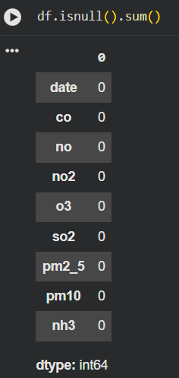
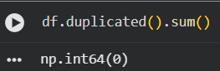


- Exploratory Data Analysis (EDA)
  - Created histograms to study the distribution of PM2.5 and PM10.
  - Used box plots to detect outliers.
  - Created a scatter plot to examine the relationship between PM2.5 and PM10.
  - Generated a correlation heatmap to understand relationships among pollutants.
  - Used a pair plot to compare multiple pollutant variables.
  - Created a line plot to observe PM2.5 trends over time.
  - Prepared a bar chart to compare the average concentration of pollutants.

Graph:
Graph 1: PM2.5 Distribution (Histogram)
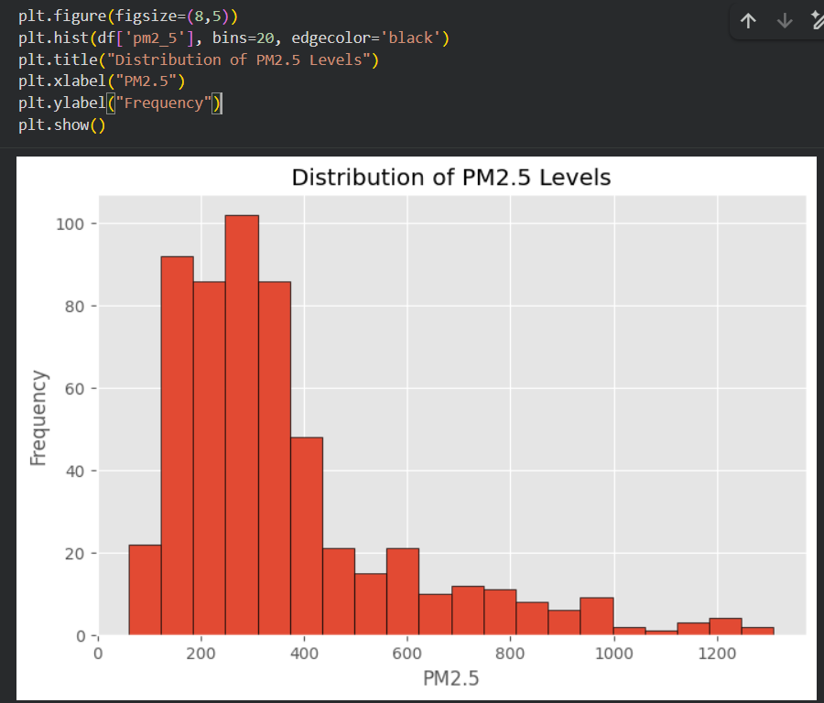
Observation:
- The histogram shows the distribution of PM2.5 values in the dataset.
- Most PM2.5 values are concentrated within a specific range, while a few extremely high values indicate severe pollution events.
- This suggests that air quality varies significantly across different days.

Graph 2: PM10 Distribution (Histogram)
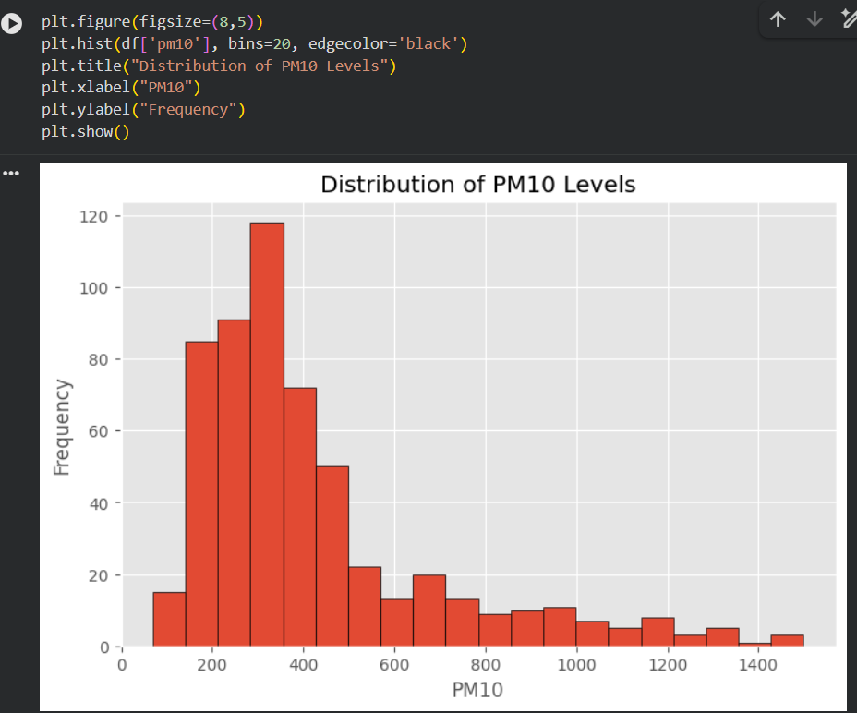
Observation:
- The PM10 values are unevenly distributed across the dataset.
- Most observations fall within the lower and middle ranges, while some high values indicate periods of increased particulate pollution.
- This highlights fluctuations in air quality over time.

Graph 3: PM2.5 Box Plot
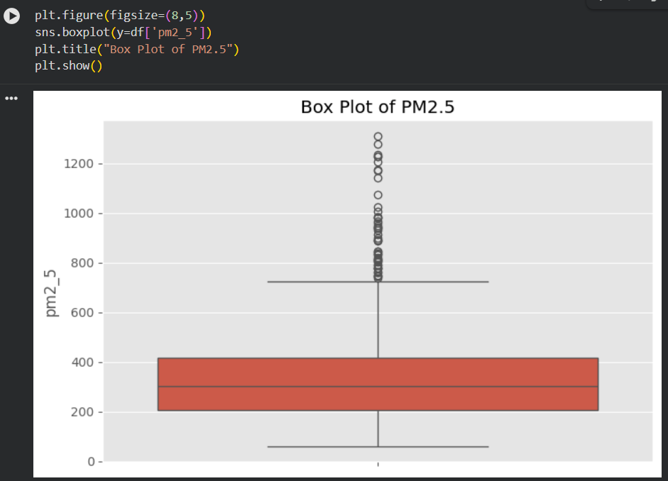
Observation:
- The box plot shows the spread and median of PM2.5 values.
- Several outliers are visible, representing days with exceptionally high PM2.5 concentrations.
- These outliers indicate occasional episodes of poor air quality.

Graph 4: PM10 Box Plot
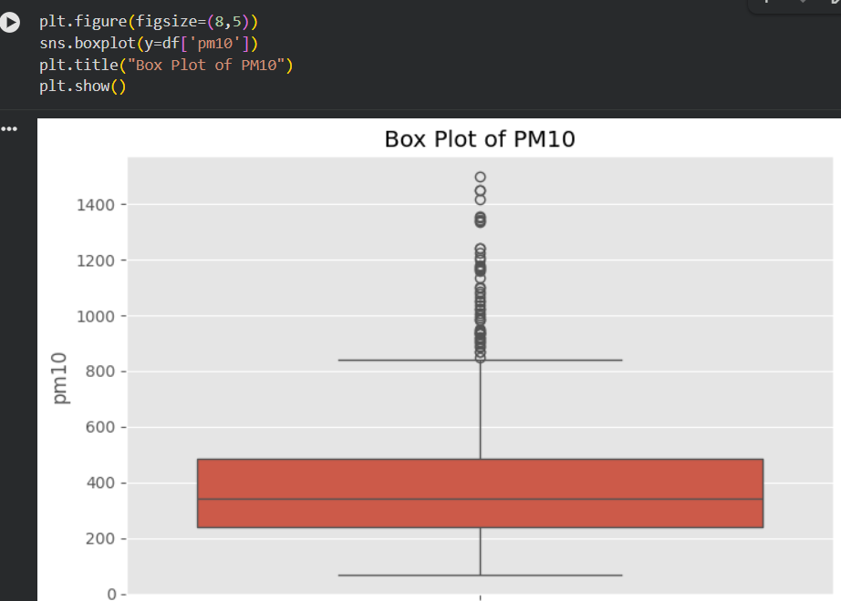
Observation:
- The PM10 box plot reveals variation in particulate matter levels.
- The presence of outliers suggests that PM10 concentrations occasionally rise far above normal levels.
- This indicates that some days experience significantly higher dust or particulate pollution.

Graph 5: Scatter Plot (PM2.5 vs PM10)
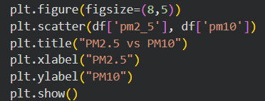
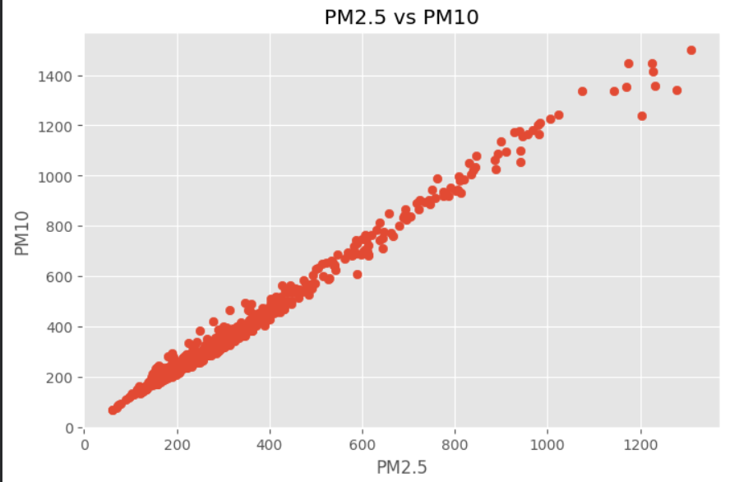

Observation:
- The PM10 box plot reveals variation in particulate matter levels.
- The presence of outliers suggests that PM10 concentrations occasionally rise far above normal levels.
- This indicates that some days experience significantly higher dust or particulate pollution.

Graph 6: Correlation Heatmap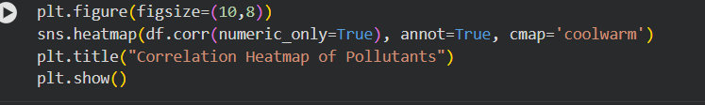
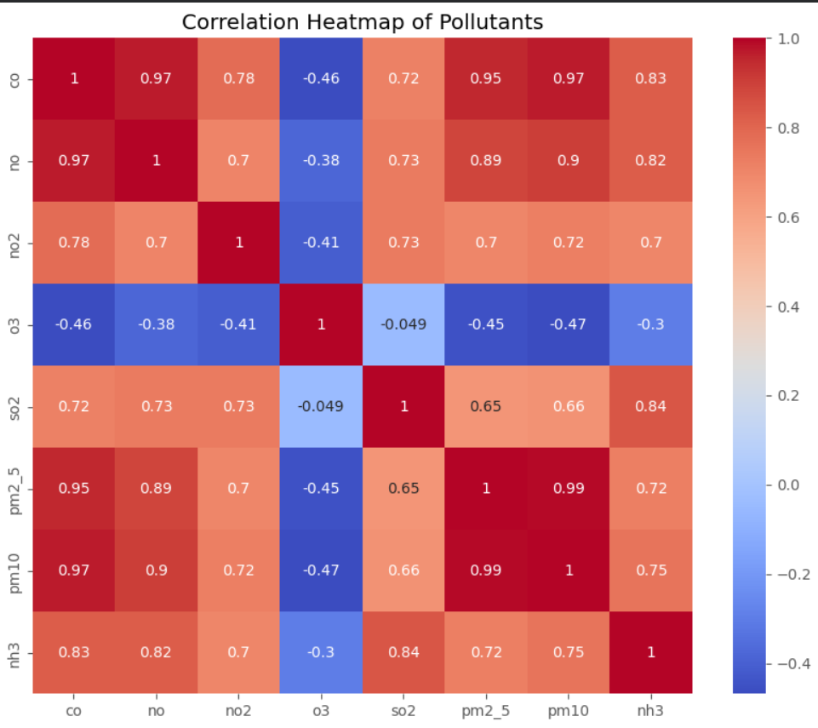
Observation:
- The heatmap displays the correlation among different air pollutants.
- Darker colors and higher correlation values indicate stronger relationships.
- It helps identify which pollutants increase or decrease together.

Graph 7: Pair Plot
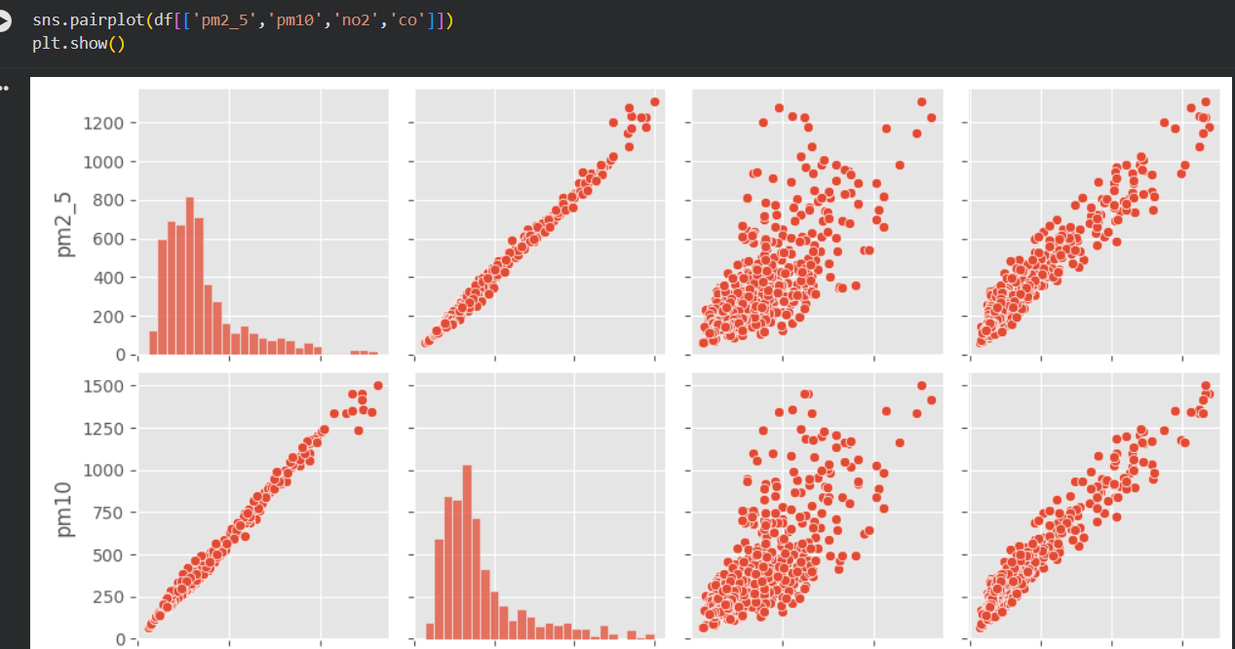
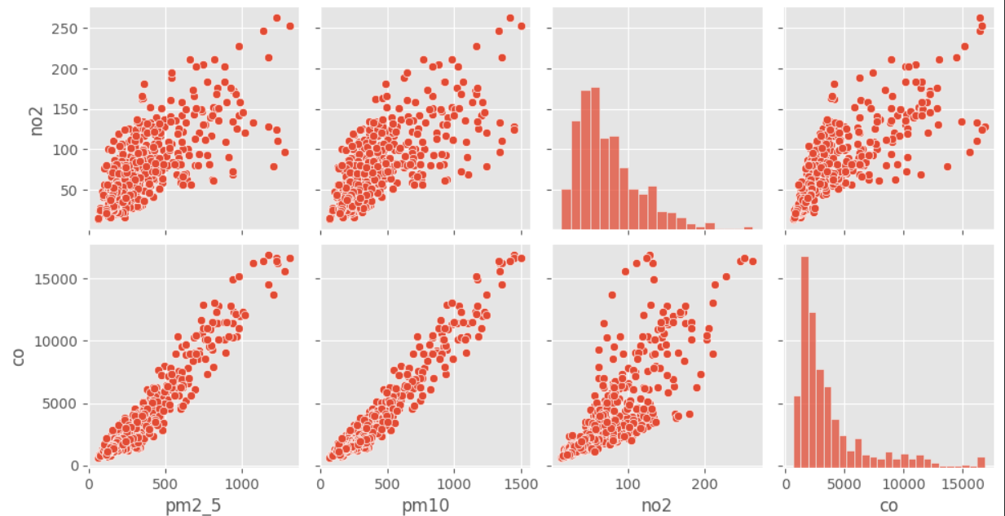
Observation:
- The pair plot compares the relationships among multiple pollutants.
- It provides both the distribution of individual variables and their pairwise relationships.
- This visualization helps identify trends, clusters, and possible correlations.
Graph 8: PM2.5 Trend Over Time
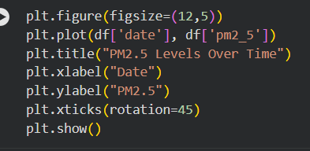
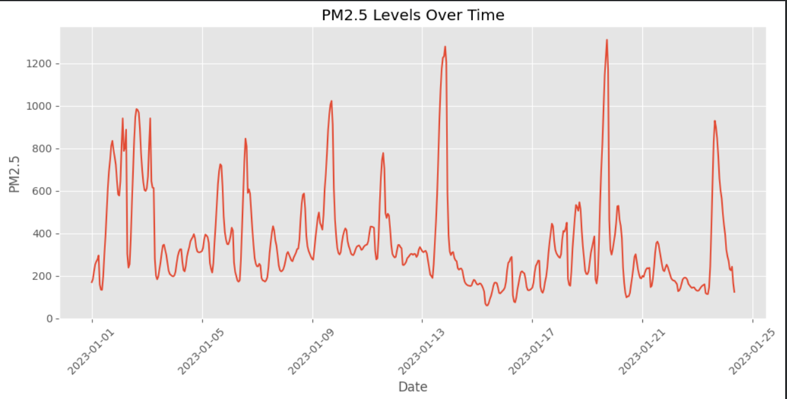
Observation:
- The line plot shows how PM2.5 levels change over time.
- Pollution levels fluctuate considerably rather than remaining constant.
- This indicates that air quality is influenced by changing environmental conditions.

Graph 9: Average Pollutant Levels
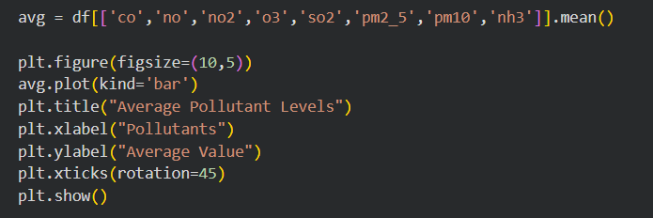
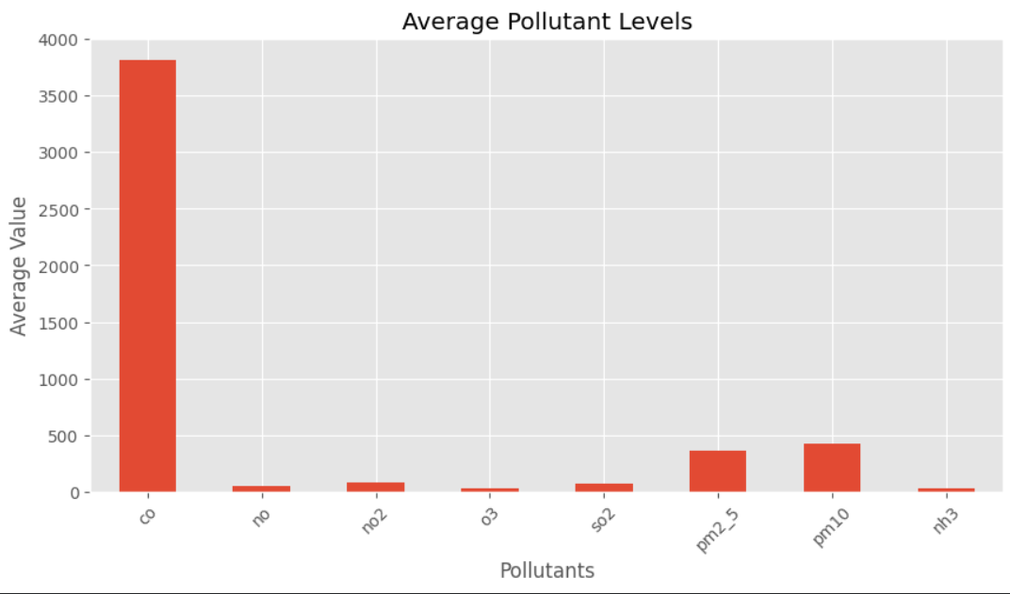
Observation:
- The bar chart compares the average concentration of different pollutants.
- It helps identify which pollutants have higher average values in the dataset.
- This comparison provides a clear overview of the relative levels of each pollutant.

# Observations
1. PM2.5 values show significant variation, indicating fluctuating air quality.
2. PM10 values also vary widely, with some days having much higher pollution levels.
3. The box plots reveal the presence of outliers, suggesting occasional extreme pollution events.
4. The scatter plot indicates a positive relationship between PM2.5 and PM10.
5. The heatmap shows correlations among pollutants, helping identify which pollutants tend to increase together.
6. The line plot shows that pollution levels change over time rather than remaining constant.
7. The average pollutant chart highlights the pollutants with the highest average concentrations.

# Insights
- PM2.5 and PM10 are the dominant pollutants in the dataset.
- A positive relationship exists between PM2.5 and PM10.
- Some pollutants exhibit extreme values, indicating occasional severe pollution events.
- Correlation analysis helps identify pollutants that tend to increase together.
- Data visualization simplifies the interpretation of complex environmental data.
- Identified pollution patterns and relationships among pollutants.
- Summarized the findings and highlighted the importance of data visualization in understanding air quality.
This content is tailored to the work you completed in your Intermediate project using the Delhi AQI dataset.

# Conclusion
This project analyzed the Delhi Air Quality dataset using Python. Data cleaning and exploratory data analysis were performed to understand pollution trends. Various visualizations such as histograms, box plots, scatter plots, heatmaps, pair plots, line plots, and bar charts were created using Matplotlib and Seaborn. The analysis showed that PM2.5 and PM10 are major pollutants and that pollutant levels vary over time. The project demonstrates how data visualization helps in understanding environmental data and supports informed decision-making.

